- Tech Productivity Index — TPI

Syntax :
Bwa_Development_Time = float(input("Enter Coding Time In Minutes : "))
Coding_Days = int(input("Enter number of valid recorded days: "))
TPI = Bwa_Development_Time / Coding_Days
print("\nTech Productivity Index (TPI):", round(TPI, 2), "min/day")

Output :
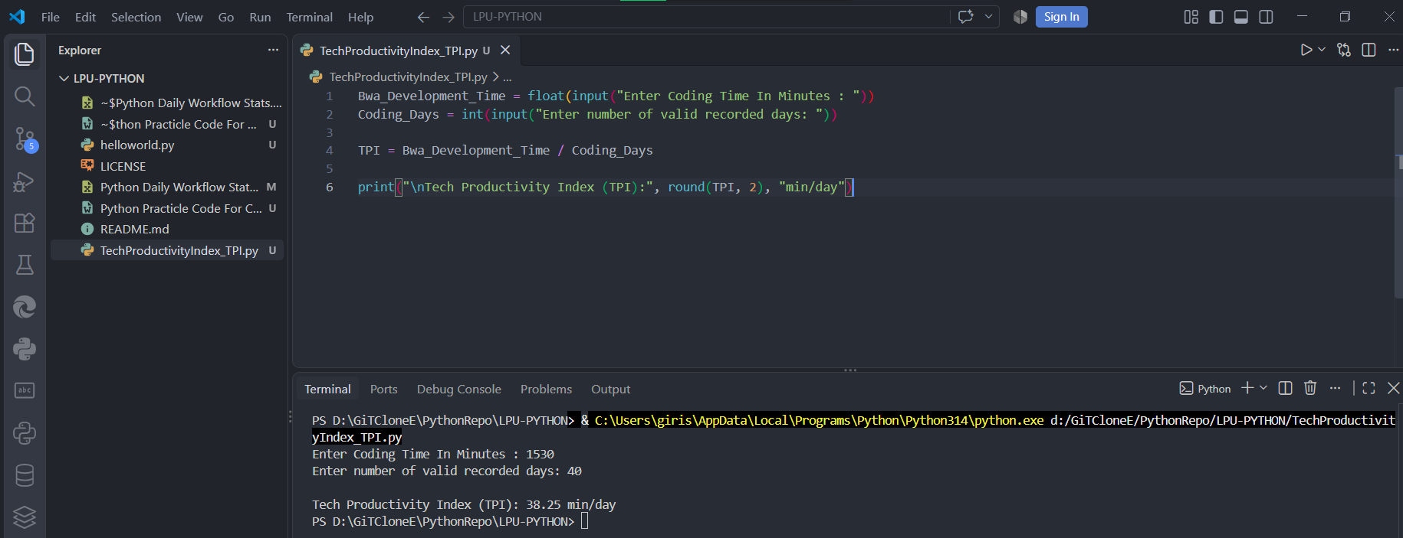

- Academic Activity Index — AAI

Syntax :

Bwa_Study_Time = float(input("Enter total study time in minutes: "))
Valid_Class_Time = float(input("Enter total class time in minutes: "))
Total_Days = int(input("Enter number of valid recorded days: "))
AAI = (Bwa_Study_Time + Valid_Class_Time) / Total_Days
print("\nAcademic Activity Index (AAI):", round(AAI, 2), "min/day")

Output :
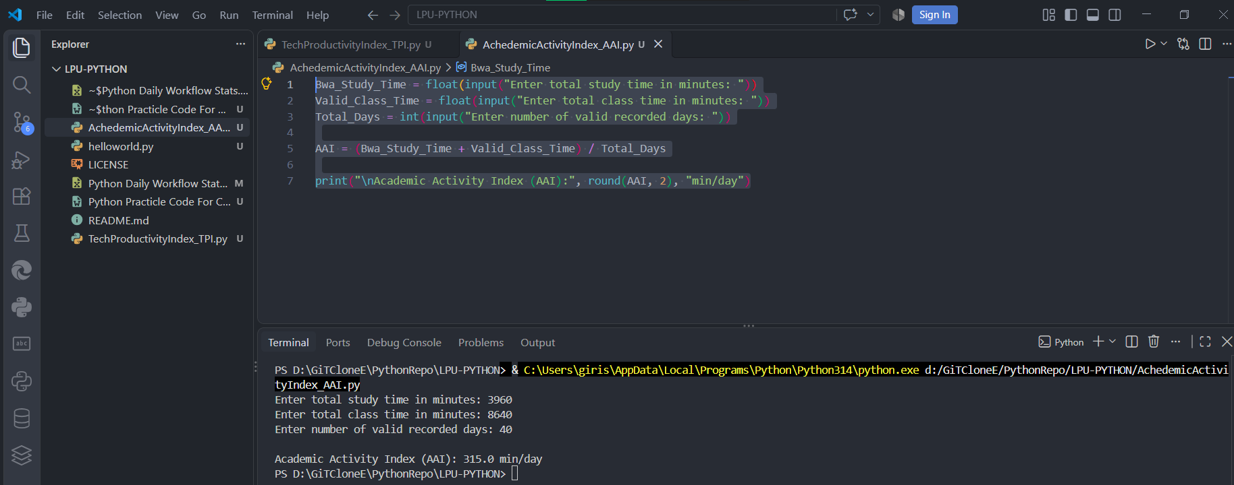

- Physical Activity Index — PhAI
Syntax :

Bwa_Workout_Time = float(input("Enter total fitness time in minutes: "))
Valid_Days = int(input("Enter number of valid recorded days: "))
PhAI = Bwa_Workout_Time / Valid_Days
print("\nPhysical Activity Index (PhAI):", round(PhAI, 2), "min/day")

Output :

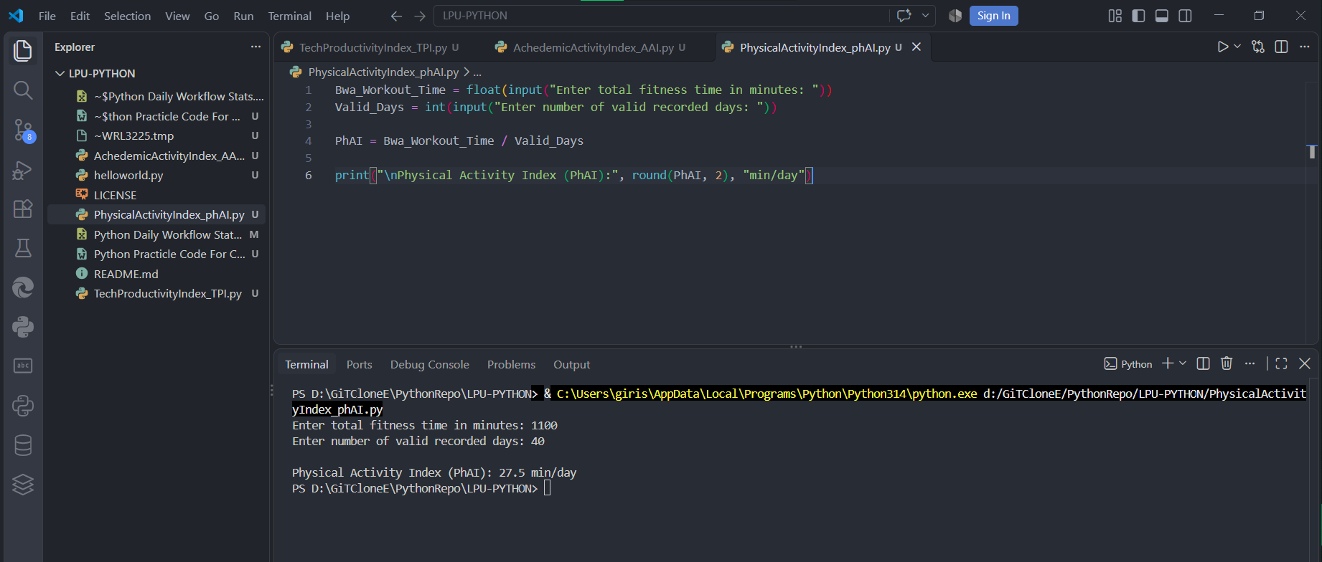

- Sleep & Recovery Index — SRI
Syntax :

Bwa_Sleep_time = float(input("Enter total sleep time in minutes: "))
Valid_Days = int(input("Enter number of valid recorded days: "))
SRI = Bwa_Sleep_time / Valid_Days
print("\nSleep & Recovery Index (SRI):", round(SRI, 2), "min/day")

Output :

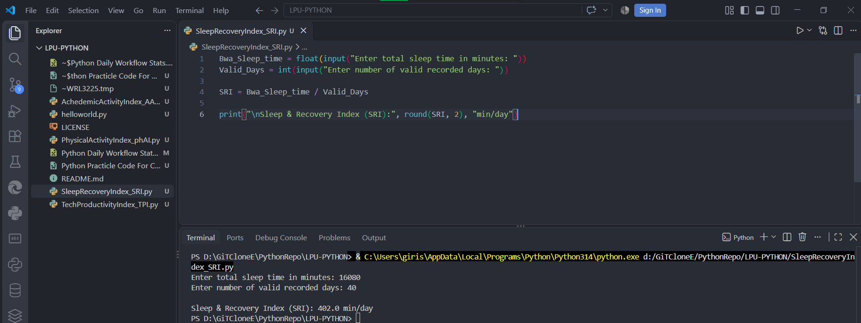

- Activity Balance Index — ABI

Syntax :

Bwa_Free_Time = float(input("Enter total free / unaccounted time in minutes: "))
Valid_Days = int(input("Enter number of valid recorded days: "))
ABI = Bwa_Free_Time / Valid_Days
print("\nActivity Balance Index (ABI):", round(ABI, 2), "min/day")

Output :

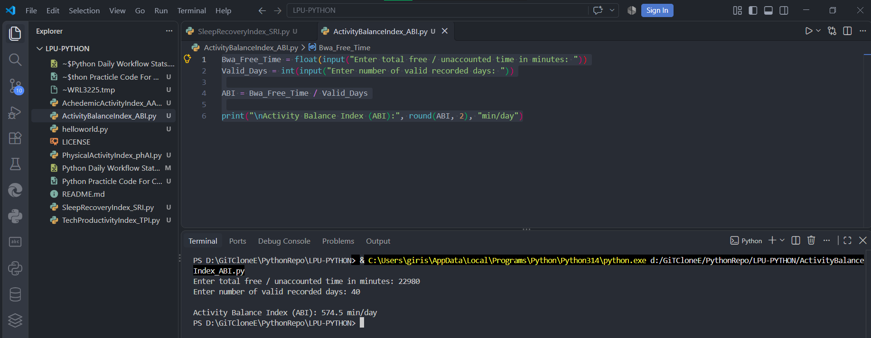

- Time Utilization Index — TUI
Syntax :

total_tracked_time = float(input("Enter total tracked time in minutes: "))
valid_days = int(input("Enter number of valid recorded days: "))
TUI = total_tracked_time / valid_days
print("\nTime Utilization Index (TUI):", round(TUI, 2), "min/day")

Output :

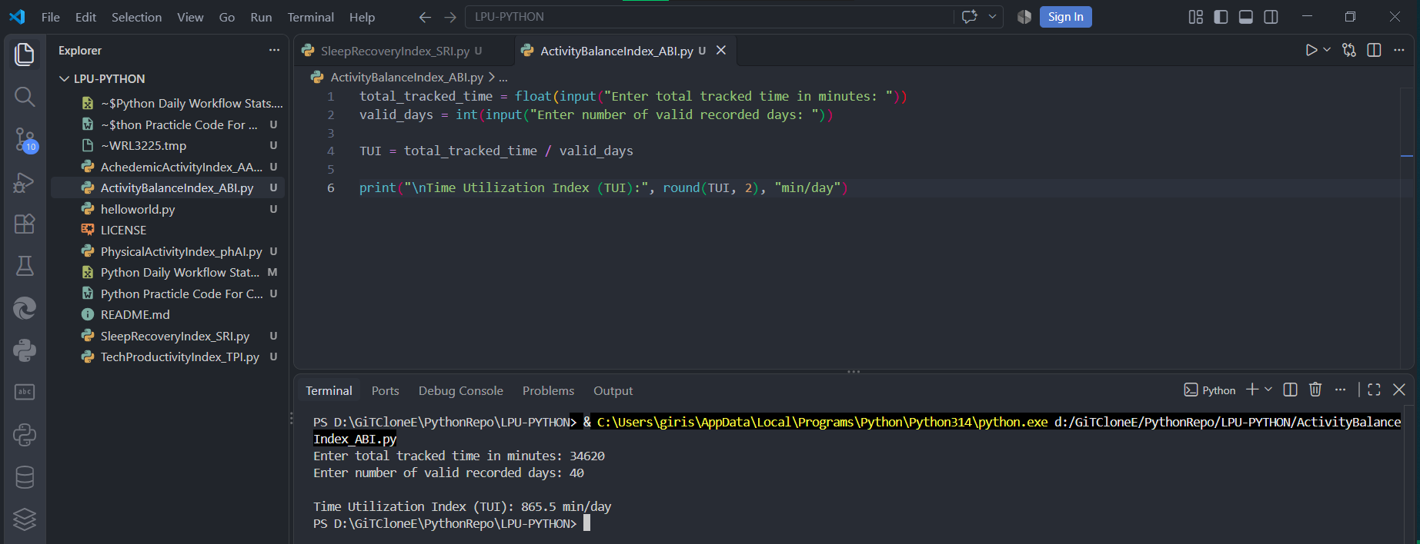

- Experience Index — EI

Syntax :

RealCalculatedFeelings = float(input("Enter average feeling score (out of 5): "))
RealCalculatedsatisfaction = float(input("Enter average satisfaction score (out of 5): "))
CalculatedEnergy = float(input("Enter average energy score (out of 5): "))
EI = (RealCalculatedFeelings + RealCalculatedsatisfaction + CalculatedEnergy) / 3
print("\nExperience Index (EI):", round(EI, 2), "/ 5")

Output :

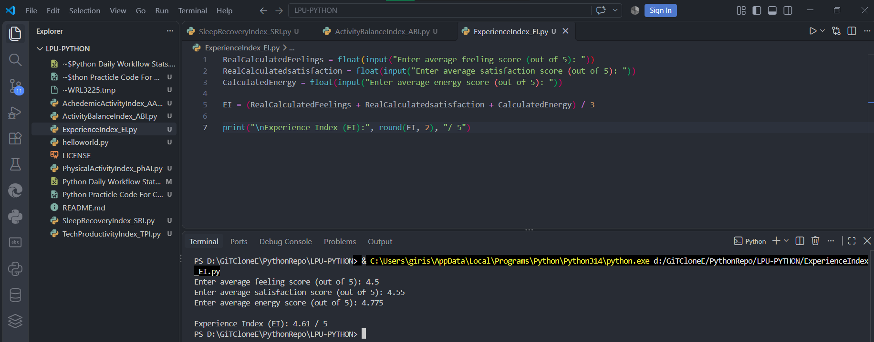

- Data Continuity Index — DCI
Syntax :

Bwa_Expected_Days = int(input("Enter expected number of days: "))
Valid_Days = int(input("Enter valid recorded days: "))
DCI = (Valid_Days / Bwa_Expected_Days) * 100
print("\nData Continuity Index (DCI):", round(DCI, 2), "%")

Output :

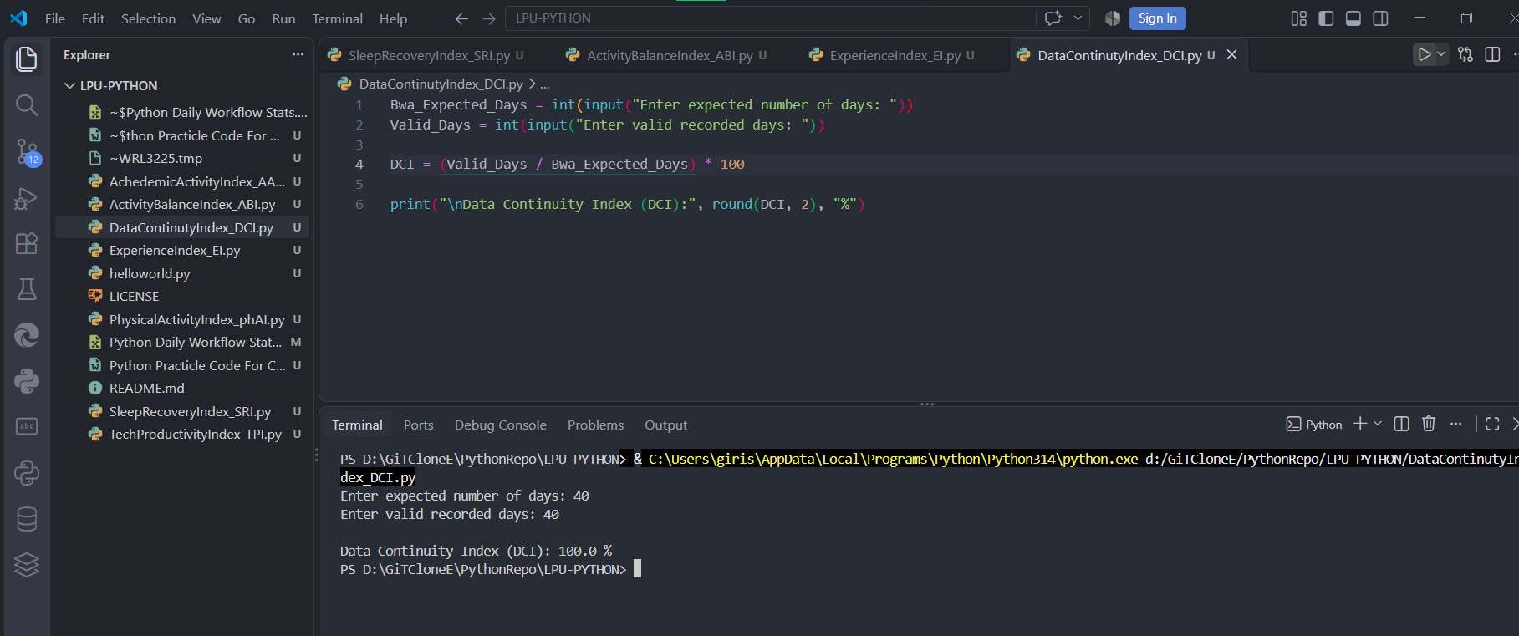

- Personal Activity Index — PAI
Syntax :
TPI = float(input("Enter TPI: "))
AAI = float(input("Enter AAI: "))
PhAI = float(input("Enter PhAI: "))
SRI = float(input("Enter SRI: "))
TUI = float(input("Enter TUI: "))
EI = float(input("Enter EI: "))
DCI = float(input("Enter DCI: "))
PAI = (
0.15 * TPI + 0.20 * AAI + 0.15 * PhAI + 0.20 * SRI + 0.15 * TUI + 0.10 * EI + 0.05 * DCI
)
print("\nPersonal Activity Index (PAI):", round(PAI, 2))

Output :
